EMBOSS course

http://ebiokit/tutorials/EMBOSS_course/So,whatisEMBOSS02.html

So, what is EMBOSS?
EMBOSS is a free Open Source software analysis package specially developed for the needs of the molecular biology (e.g. EMBnet) user community. The software automatically copes with data in a variety of formats and even allows transparent retrieval of sequence data from the web. Also, as extensive libraries are provided with the package, it is a platform to allow other scientists to develop and release software in true open source spirit. EMBOSS also integrates a range of currently available packages and tools for sequence analysis into a seamless whole. EMBOSS breaks the historical trend towards commercial software packages.
The EMBOSS suite:
• Provides a comprehensive set of sequence analysis programs (approximately 150)
• Integrates other publicly available packages
• Encourages the use of EMBOSS in sequence analysis training.
• Encourages developers elsewhere to use the EMBOSS libraries.
• Supports all common Unix platforms including Linux, Digital Unix, Irix and Solaris.
• Within EMBOSS you will find over 150 programs (applications).
These are just some of the areas covered:
• Sequence alignment
• Rapid database searching with sequence patterns
• Protein motif identification, including domain analysis
• EST analysis
• Nucleotide sequence pattern analysis, for example to identify CpG islands.
• Simple and species-specific repeat identification
• Codon usage analysis for small genomes
• Rapid identification of sequence patterns in large scale sequence sets.
• Presentation tools for publication
• And much more.
More information about EMBOSS can be found here: http://emboss.sourceforge.net/

Exercise: wossname
Here we will introduce you to the EMBOSS utility wossname will produce a list of all the various EMBOSS applications. All programs in the EMBOSS suite have help information click on the (read the manual ) link!
Exercise:
On the commandline of the terminal type in wossname followed by PROTEIN
127:~ebiokit$ wossname PROTEIN
Finds programs by keywords in their one-line documentation
SEARCH FOR 'PROTEIN'
antigenic Finds antigenic sites in proteins
backtranambig Back translate a protein sequence to ambiguous codons
backtranseq Back translate a protein sequence
charge Protein charge plot
checktrans Reports STOP codons and ORF statistics of a protein
compseq Count composition of dimer/trimer/etc words in a sequence
digest Protein proteolytic enzyme or reagent cleavage digest
emowse Protein identification by mass spectrometry
epestfind Finds PEST motifs as potential proteolytic cleavage sites
fproml Protein phylogeny by maximum likelihood
fpromlk Protein phylogeny by maximum likelihood
fprotdist Protein distance algorithm
fprotpars Protein parsimony algorithm
freak Residue/base frequency table or plot
fuzzpro Protein pattern search
fuzztran Protein pattern search after translation
garnier Predicts protein secondary structure
helixturnhelix Report nucleic acid binding motifs
hmoment Hydrophobic moment calculation
iep Calculates the isoelectric point of a protein
makeprotseq Creates random protein sequences
msbar Mutate sequence beyond all recognition
mwcontam Shows molwts that match across a set of files
mwfilter Filter noisy molwts from mass spec output
octanol Displays protein hydropathy
oddcomp Find protein sequence regions with a biased composition
patmatdb Search a protein sequence with a motif
patmatmotifs Search a PROSITE motif database with a protein sequence
pepcoil Predicts coiled coil regions
pepinfo Plots simple amino acid properties in parallel
pepnet Displays proteins as a helical net
pepstats Protein statistics
pepwheel Shows protein sequences as helices
pepwindow Displays protein hydropathy
pepwindowall Displays protein hydropathy of a set of sequences
preg Regular expression search of a protein sequence
profit Scan a sequence or database with a matrix or profile
prophecy Creates matrices/profiles from multiple alignments
prophet Gapped alignment for profiles
pscan Scans proteins using PRINTS
psiphi Phi and psi torsion angles from protein coordinates
shuffleseq Shuffles a set of sequences maintaining composition
sigcleave Reports protein signal cleavage sites
tcode Fickett TESTCODE statistic to identify protein-coding DNA
tmap Displays membrane spanning regions
tranalign Align nucleic coding regions given the aligned proteins

This set of commands will cause wossname to write out the list of programs that are associated with proteins.
To produce a list of all the current EMBOSS programs, start up wossname again but instead of specifying a keyword, just type wossname. A list of programs will scroll onto your screen, divided up into groups according to their functions. Scroll up and down to see them all.
To read the manual for each programme listed type, tfm name_of_programme
127:~ebiokit$ tfm pepinfo
This will give you information on the function of the programme and how to use it.
We'll see some more later. Let's move on to some sequence analysis...

Working with sequences, seqret

Seqret reads in a sequence, and writes it out, in the format that you need. It is probably the most commonly used EMBOSS program. You do not need any format converter, use seqret!
Exercise: seqret
Download the file L0770.embl to your directory and convert it to a fasta format file using the EMBOSS command seqret. Inspect the downloaded file using a text editor.
It will look like this:
ID L07770; SV 1; linear; mRNA; STD; VRT; 1684 BP.
XX
AC L07770;
XX
DT 12-DEC-1992 (Rel. 34, Created)
DT 17-APR-2005 (Rel. 83, Last updated, Version 8)
XX
DE Xenopus laevis rhodopsin mRNA, complete cds.
XX
KW G protein-coupled receptor; phototransduction protein; retinal protein;
KW rhodopsin; transmembrane protein.
XX
OS Xenopus laevis (African clawed frog)
OC Eukaryota; Metazoa; Chordata; Craniata; Vertebrata; Euteleostomi; Amphibia;
OC Batrachia; Anura; Mesobatrachia; Pipoidea; Pipidae; Xenopodinae; Xenopus;
OC Xenopus.
XX
RN [1]
RP 1-1684
RA Knox B.E., Scalzetti L.C., Batni S., Wang J.Q.;
RT "Molecular cloning of the abundant rhodopsin and transducin from Xenopus
RT laevis";
RL Unpublished.
XX
RN [2]
RP 1-1684
RX DOI; 10.1074/jbc.271.6.3179.
RX PUBMED; 8621718.
RA Batni S., Scalzetti L., Moody S.A., Knox B.E.;
RT "Characterization of the Xenopus rhodopsin gene";
RL J. Biol. Chem. 271(6):3179-3186(1996).
XX
SQ Sequence 1684 BP; 426 A; 431 C; 339 G; 488 T; 0 other;
ggtagaacag cttcagttgg gatcacaggc ttctagggat cctttgggca aaaaagaaac 60
acagaaggca ttctttctat acaagaaagg actttataga gctgctacca tgaacggaac 120
agaaggtcca aatttttatg tccccatgtc caacaaaact ggggtggtac gaagcccatt 180
cgattaccct cagtattact tagcagagcc atggcaatat tcagcactgg ctgcttacat 240
gttcctgctc atcctgcttg ggttaccaat caacttcatg accttgtttg ttaccatcca 300
gcacaagaaa ctcagaacac ccctaaacta catcctgctg aacctggtat ttgccaatca 360
cttcatggtc ctgtgtgggt tcacggtgac aatgtacacc tcaatgcacg gctacttcat 420
ctttggccaa actggttgct acattgaagg cttctttgct acacttggtg gtgaagtggc 480
cctctggtca ctggtagtat tggccgttga aagatatatg gtggtctgca agcccatggc 540
caacttccga ttcggggaga accatgctat tatgggtgta gccttcacat ggatcatggc 600
tttgtcttgt gctgctcctc ctctcttcgg atggtccaga tacatcccag agggaatgca 660
atgctcatgc ggagtagact actacacact gaagcctgag gtcaacaatg aatcctttgt 720
tatctacatg ttcattgtcc acttcaccat tcccctgatt gtcatcttct tctgctatgg 780
tcgcctgctc tgcactgtca aagaggctgc agcccagcaa caggaatctg ctaccaccca 840
gaaggctgag aaagaggtca ccagaatggt tgttatcatg gtcgttttct tcctgatctg 900
ttgggtgccc tatgcctatg tggcattcta catcttcacc caccagggct ctaactttgg 960
cccagtcttc atgaccgtcc cagctttctt tgccaagagc tctgctatct acaatcctgt 1020
catctacatt gtcttgaaca aacagttccg taactgcttg atcaccaccc tgtgctgtgg 1080
aaagaatcca ttcggtgatg aagatggctc ctctgcagcc acctccaaga cagaagcttc 1140
ttctgtctct tccagccagg tgtctcctgc ataagagctt caccagggct gtctcagggt 1200
ccgctgcctc acacaattcc catcacttaa gccctgtcta cttgttgcga aggcaaagaa 1260
ttccacagtt ttaatattta cccccattct gcccaacctt ggacactgta agagctgacc 1320
ccattactgc tgggaaggcc caagctttgt tgcattctga tgtgatcctt tcagcagaaa 1380
atgggtggat tcaatgaatt tcaccaaggc tgtacataac aataacatta gtctgaaggc 1440
acctcccacc cagagaatgc aacacttatt tatctctgtc ttttcttgac atattgatgc 1500
tgcttctatt catggtcact aacaaaaagt cccattttac aatgcaactg aaagtaatgt 1560
atttttgtaa tataataaca tatttcatgc aatctcctct gcttattggc aaggtctgat 1620
atagtgagga tagacagcca gaccccttgc attaaaatcc tgtattaaaa atttctttgc 1680
aagt 1684
//
On the commandline type the following:

$ seqret L07770.embl -osformat fasta
Reads and writes (returns) sequences
output sequence(s) [l07770.fasta]:

Look at the resulting file.
You should get the same sequence l07770.fasta:
Look at the result:

>L07770 L07770.1 Xenopus laevis rhodopsin mRNA, complete cds.
ggtagaacagcttcagttgggatcacaggcttctagggatcctttgggcaaaaaagaaac
acagaaggcattctttctatacaagaaaggactttatagagctgctaccatgaacggaac
agaaggtccaaatttttatgtccccatgtccaacaaaactggggtggtacgaagcccatt
cgattaccctcagtattacttagcagagccatggcaatattcagcactggctgcttacat
gttcctgctcatcctgcttgggttaccaatcaacttcatgaccttgtttgttaccatcca
gcacaagaaactcagaacacccctaaactacatcctgctgaacctggtatttgccaatca
cttcatggtcctgtgtgggttcacggtgacaatgtacacctcaatgcacggctacttcat
ctttggccaaactggttgctacattgaaggcttctttgctacacttggtggtgaagtggc
cctctggtcactggtagtattggccgttgaaagatatatggtggtctgcaagcccatggc
caacttccgattcggggagaaccatgctattatgggtgtagccttcacatggatcatggc
tttgtcttgtgctgctcctcctctcttcggatggtccagatacatcccagagggaatgca
atgctcatgcggagtagactactacacactgaagcctgaggtcaacaatgaatcctttgt
tatctacatgttcattgtccacttcaccattcccctgattgtcatcttcttctgctatgg
tcgcctgctctgcactgtcaaagaggctgcagcccagcaacaggaatctgctaccaccca
gaaggctgagaaagaggtcaccagaatggttgttatcatggtcgttttcttcctgatctg
ttgggtgccctatgcctatgtggcattctacatcttcacccaccagggctctaactttgg
cccagtcttcatgaccgtcccagctttctttgccaagagctctgctatctacaatcctgt
catctacattgtcttgaacaaacagttccgtaactgcttgatcaccaccctgtgctgtgg......

Pairwise sequence alignment
This chapter is about sequence similarity. Let us start with a warning: there is no unique, precise, or universally applicable notion of similarity. An alignment is an arrangement of two sequences, which shows where the two sequences are similar, and where they differ. An optimal alignment, of course, is one that exhibits the most similarities, and the least differences. Broadly, there are three categories of methods for sequence comparison.
•Segment methods compare all overlapping segments of a predetermined length (e.g., 10 amino acids) from one sequence to all segments from the other. This is the approach used in dotplots.
•Optimal global alignment methods allow the best overall score for the comparison of the two sequences to be obtained, including a consideration of gaps.
•Optimal local alignment algorithms seek to identify the best local similarities between two sequences but, unlike segment methods, include explicit consideration of gaps.
Dotplots
The most intuitive representation of the comparison between two sequences uses dot-plots. One sequence is represented on each axis and significant matching regions are distributed along diagonals in the matrix.
Exercise: Making a dotplot
Program: dottup
Displays a wordmatch dotplot of two sequences
Parameters:
Input sequence: xl23808
Second sequence: xlrhodop
(Pay attention that the second letter after x is the letter l and not number 1 (one)
Word size [4]: 10
Graph type [x11]: (Will send the image to your screen. Alternatively type in png or gif to produce a png image to load into a word processing document)
The resulting image should look like this:
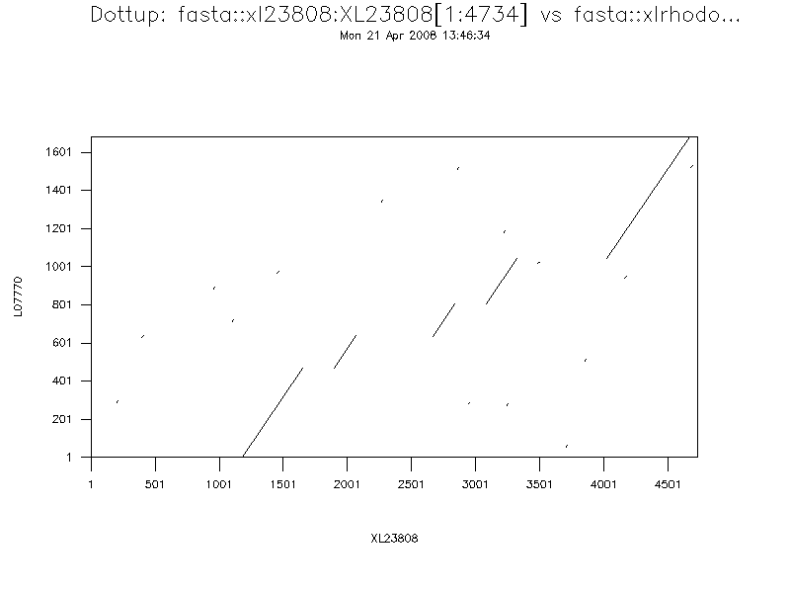
The diagonal lines represent areas where the two sequences align well. You can see that there are five clear diagonals. You will remember that we are aligning genomic and cDNA - these five diagonals represent the five exons of the gene! To confirm this, we need to do a more rigorous analysis. For this we will perform a pairwise alignment.
The basic idea behind the sequence alignment programs is to align the two sequences in such a way as to produce the highest score - a scoring matrix is used to add points to the score for each match and subtract them for each mismatch. The matrices used for nucleic acid alignments tend to involve fairly simple match/mismatch scoring schemes, while the matrices commonly used for scoring protein alignments are more complex, with scores designed to reflect similarity between the different amino acids rather than simply scoring identities. Over time various mutations occur in sequences; the scoring matrices attempt to cope with mutations, but insertions and deletions require some extra parameters to allow the introduction of gaps in the alignment. There are penalties both for the creation of gaps and for the extension of existing ones; the default gap parameters given in alignment programs have been found to be empirically correct with test sequences but you should experiment with different gap penalties.

Global alignment
A global alignment is one that compares the two sequences over their entire lengths, and is appropriate for comparing sequences that are expected to share similarity over the whole length. The alignment maximises regions of similarity and minimises gaps using the scoring matrices and gap parameters provided to the program. The EMBOSS program needle is an implementation of the Needleman-Wunsch [3] algorithm for global alignment; the computation is rigorous and needle can be time consuming to run if the sequences are long.
Exercise: needle
Program: needle
(Needleman-Wunsch global alignment).
Input sequence: xlrhodop
Second sequence: xl23808
Gap opening penalty [10.0]:
Gap extension penalty [0.5]:

Result:
########################################
# Program: needle
# Rundate: Mon 21 Apr 2008 14:04:19
# Commandline: needle
# -asequence xlrhodop
# -sbegin1 1
# -send1 1684
# -bsequence xl23808
# -gapopen 10.0
# -gapextend 0.5
# -brief
# -aformat srspair
# -auto
# Align_format: srspair
# Report_file: .needle.08.04.21:14.04.19/l07770.needle
########################################
#=======================================
#
# Aligned_sequences: 2
# 1: L07770
# 2: XL23808
# Matrix: EDNAFULL
# Gap_penalty: 10.0
# Extend_penalty: 0.5
#
# Length: 4734
# Identity: 1683/4734 (35.6%)
# Similarity: 1683/4734 (35.6%)
# Gaps: 3050/4734 (64.4%)
# Score: 7471.0
#
#
#=======================================
XL23808 1101 aatcctttgttcgtgacgctgggggttgcaagcttactccaggtgggact 1150
L07770 1 ------------------------------ggtagaacagcttcagttgg 20
.|||||||||||||||||||
XL23808 1151 ttaaaaggacgaggggacagtgggtcatactgtagaacagcttcagttgg 1200
L07770 21 gatcacaggcttctagggatcctttgggcaaaaaagaaacacagaaggca 70
||||||||||||||||||||||||||||||||||||||||||||||||||
XL23808 1201 gatcacaggcttctagggatcctttgggcaaaaaagaaacacagaaggca 1250
We've only shown part of the output, as it is very long. You should look at the whole output and note that there are five aligned regions that represent the five exons as predicted from the previous dotplot.

Local alignment
As we mentioned above, global sequence alignment algorithms align sequences over their entire lengths. You do need to think about whether that type of alignment makes sense for your sequences. For our example, where we expect each exon to be represented in the sequences and in the same order, it has worked well - however, how well do you think this approach would work with, for example, multidomain proteins that share one domain but not others, or sequences where there have been regions of duplication? A second comparison method, local alignment, searches for regions of local similarity and need not include the entire length of the sequences. Local alignment methods are very useful for scanning databases or when you do not know that the sequences are similar over their entire lengths. The EMBOSS program water is a rigorous implementation of the Smith Waterman algorithm for local alignments [4].
Exercise: water
Program: water
Smith-Waterman local alignment.
Input sequence: xlrhodop
Second sequence: xl23808
Gap opening penalty [10.0]:
Gap extension penalty [0.5]:
Result:
########################################
# Program: water
# Rundate: Mon 21 Apr 2008 14:12:32
# Commandline: water
# -asequence xl23808
# -sbegin1 1
# -send1 4734
# -bsequence xlrhodop
# -gapopen 10.0
# -gapextend 0.5
# -brief
# -aformat srspair
# -auto
# Align_format: srspair
# Report_file: .water.08.04.21:14.12.31/xl23808.water
########################################
#=======================================
#
# Aligned_sequences: 2
# 1: XL23808
# 2: L07770
# Matrix: EDNAFULL
# Gap_penalty: 10.0
# Extend_penalty: 0.5
#
# Length: 3487
# Identity: 1683/3487 (48.3%)
# Similarity: 1683/3487 (48.3%)
# Gaps: 1804/3487 (51.7%)
# Score: 7475.0
#
#
#=======================================
XL23808 1182 gtagaacagcttcagttgggatcacaggcttctagggatcctttgggcaa 1231
||||||||||||||||||||||||||||||||||||||||||||||||||
L07770 2 gtagaacagcttcagttgggatcacaggcttctagggatcctttgggcaa 51
XL23808 1232 aaaagaaacacagaaggcattctttctatacaagaaaggactttatagag 1281
||||||||||||||||||||||||||||||||||||||||||||||||||
L07770 52 aaaagaaacacagaaggcattctttctatacaagaaaggactttatagag 101
Scroll down the entire output and again, note that five exons have been found.
In these cases we have not had to adjust the gap parameters from the defaults used in these programs. You should be aware that you might need to do so with your own sequences.
EMBOSS contains other pairwise alignment programs - stretcher and matcher are global and local alignment programs respectively that are less rigorous than needle and water and therefore run more quickly; they may be useful for database searching.
Supermatcher is designed for local alignments of very large sequences and is even less rigorous in its implementation. The documentation pages for all these programs can be found at www.emboss.org

Protein analysis
This chapter will introduce you to a few of the EMBOSS applications that can be used to analyze protein sequences. Obviously, the pairwise sequence comparison methods illustrated in the previous chapter with nucleic acid sequences can also be used with protein sequences.
•Identifying the ORF
•Exercise: plotorf
•Exercise: getorf
•Translating the sequence
•Exercise: transeq
•Secondary structure prediction
•pepinfo
•Exercise: pepinfo
•Predicting transmembrane regions
•Exercise: tmap

Identifying the ORF
In this section we'll show you some simple EMBOSS applications for translating your cDNA sequence into protein. You should be aware that gene structure prediction is a tough problem, and recognising exon/intron boundaries in genomic sequence is not easy; for now, rather than deal with that aspect of prediction, we'll use the cDNA sequence in our practical. First, we need to identify our open reading frame. We can get a rapid visual overview of the distribution of ORFs in the six frames of our sequence using the EMBOSS program plotorf.
Exercise: plotorf
Program: plotorf
Plot potential open reading frames Input sequence: xlrhodop
Graph type [png]:
You will see a graphical output that shows the potential open reading frames (ORF) in all six frames:
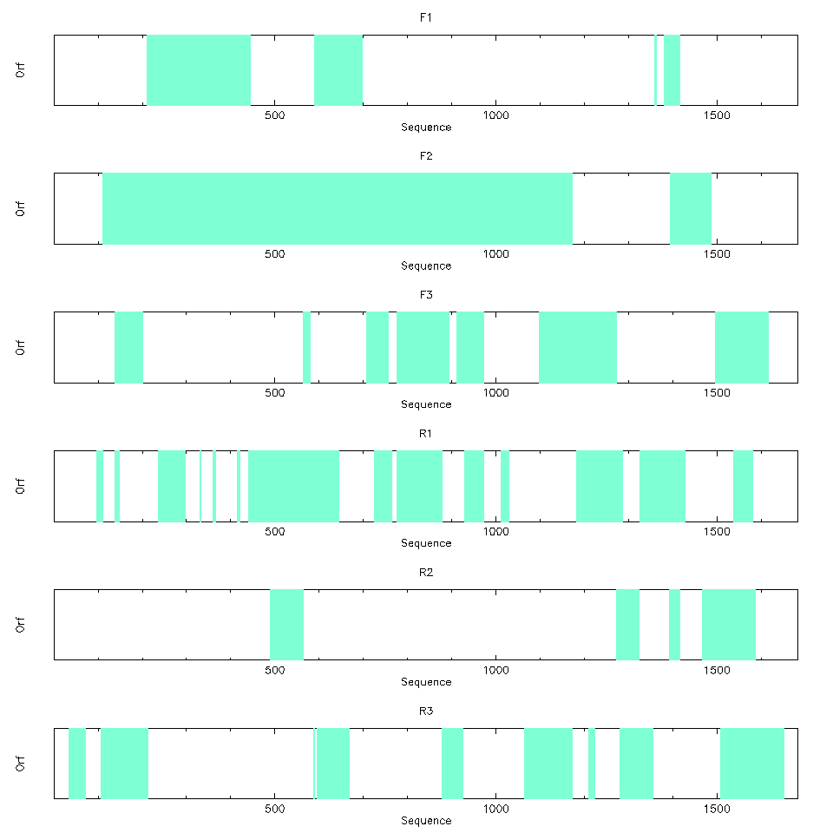

Exercise: getorf
Program: getorf -opt
Finds and extracts open reading frames (ORFs)
Input sequence: xlrhodop
Make the choices:
Begin: 100
End: 2000 (this we know from plotorf)
Minimum nucleotide size of ORF to report: 0
Maximum nucleotide size of ORF to report: 1000000
Type of output: Nucleic sequence between START and STOP codons
Run getorf
Notice that you can specify the organism whose codon usage table is most appropriate for your sequence, and you can also choose the type of information that is reported to you. In our case, we are simply interested in the positions of the start and stop codons for this sequence. Plotorf is just a graphical representation of the textual information produced by getorf. Since we asked for all ORFs above a minimum size to be reported, getorf is telling us about a number of potential ORFs. We know from plotorf that our ORF will be in the region 0 to 1200, so scroll through the output file, xlrhodop.orf, until you identify this. What are the actual start and end positions?
Result:
>L07770_7 [110 - 1171] Xenopus laevis rhodopsin mRNA, complete cds.
atgaacggaacagaaggtccaaatttttatgtccccatgtccaacaaaactggggtggta
cgaagcccattcgattaccctcagtattacttagcagagccatggcaatattcagcactg
gctgcttacatgttcctgctcatcctgcttgggttaccaatcaacttcatgaccttgttt
gttaccatccagcacaagaaactcagaacacccctaaactacatcctgctgaacctggta
tttgccaatcacttcatggtcctgtgtgggttcacggtgacaatgtacacctcaatgcac
ggctacttcatctttggccaaactggttgctacattgaaggcttctttgctacacttggt
ggtgaagtggccctctggtcactggtagtattggccgttgaaagatatatggtggtctgc
aagcccatggccaacttccgattcggggagaaccatgctattatgggtgtagccttcaca
tggatcatggctttgtcttgtgctgctcctcctctcttcggatggtccagatacatccca
gagggaatgcaatgctcatgcggagtagactactacacactgaagcctgaggtcaacaat
gaatcctttgttatctacatgttcattgtccacttcaccattcccctgattgtcatcttc
ttctgctatggtcgcctgctctgcactgtcaaagaggctgcagcccagcaacaggaatct
gctaccacccagaaggctgagaaagaggtcaccagaatggttgttatcatggtcgttttc
ttcctgatctgttgggtgccctatgcctatgtggcattctacatcttcacccaccagggc
tctaactttggcccagtcttcatgaccgtcccagctttctttgccaagagctctgctatc
tacaatcctgtcatctacattgtcttgaacaaacagttccgtaactgcttgatcaccacc
ctgtgctgtggaaagaatccattcggtgatgaagatggctcctctgcagccacctccaag
acagaagcttcttctgtctcttccagccaggtgtctcctgca

Translating the sequence
From the previous exercise you should have found that the region to be translated is from 110 to 1171 in our cDNA sequence.
Now we can use transeq to translate that region and use the translated peptide for some further analyses.
Let's practice with the program transeq. Specify the subregion of your sequence; in this case we will ask transeq to translate only the part of xlrhodop that we have identified as the coding region.
Exercise: transeq
transeq xlrhodop
Begin: 110
End: 1171
run transeq
Translate nucleic acid sequences
Result:
>L07770_1 Xenopus laevis rhodopsin mRNA, complete cds.
MNGTEGPNFYVPMSNKTGVVRSPFDYPQYYLAEPWQYSALAAYMFLLILLGLPINFMTLF
VTIQHKKLRTPLNYILLNLVFANHFMVLCGFTVTMYTSMHGYFIFGQTGCYIEGFFATLG
GEVALWSLVVLAVERYMVVCKPMANFRFGENHAIMGVAFTWIMALSCAAPPLFGWSRYIP
EGMQCSCGVDYYTLKPEVNNESFVIYMFIVHFTIPLIVIFFCYGRLLCTVKEAAAQQQES
ATTQKAEKEVTRMVVIMVVFFLICWVPYAYVAFYIFTHQGSNFGPVFMTVPAFFAKSSAI
YNPVIYIVLNKQFRNCLITTLCCGKNPFGDEDGSSAATSKTEASSVSSSQVSPA
Save as x1rhodop.pep

Secondary structure prediction
The question of how DNA sequence determines specific protein structure has been a constant source of fascination and speculation since the problem was identified. It remains an extremely difficult area; generally referred to as the ``folding problem'', it is one of the major outstanding questions in molecular biology. Many attempts have been made to predict the tertiary structure of a protein from its sequence. These fall into two distinct approaches:
•One approach is to set up a realistic mechanical model of the protein chain and simulate the folding process.
•Other approaches are empirical as they proceed by inference from known tertiary structures.
The approach to structure prediction based on mechanical models has the innate (possibly fatal) attraction that, in theory, it requires no prior knowledge of protein tertiary structure. If successful it could be applied uniformly to all sequences. By contrast, all methods based on inference from known structures are inherently limited in their applicability. They will only be appropriate for predicting structures similar to those, which were used in the inference process. Fortunately there are often biophysical or biochemical clues that help make this decision and these are often integrated in the methods for structure prediction.
Currently the best way to achieve reasonable secondary structure predictions is to run a variety of prediction algorithms over your sequence and determine a consensus among the results. There are various web servers that will do these multiple analyses for you.
As yet, coverage of secondary structure prediction within EMBOSS is limited. More algorithms will be added to enable the consensus approach described above. We'll take a look now at some of the predictions you can currently perform using EMBOSS.
•pepinfo
•Exercise: pepinfo
•Predicting transmembrane regions
•Exercise: tmap

Pepinfo
Pepinfo produces information on amino acid properties (size, polarity, aromaticity, charge etc). Hydrophobicity profiles are also available and are useful for locating turns, potential antigenic peptides and transmembrane helices. Various algorithms are employed including the Kyte and Doolittle hydropathy measure - this curve is the average of a residue-specific hydrophobicity index over a window of nine residues. When the line is in the upper half of the frame, it indicates a hydrophobic region, and when it is in the lower half, a hydrophilic region.
Exercise: pepinfo
Program: pepinfo
choose xlrhodop.pep
Remember that you produced this in a previous exercise.
Plots simple amino acid properties in parallel
Graph type [png]:
You will see pictures that look like this:
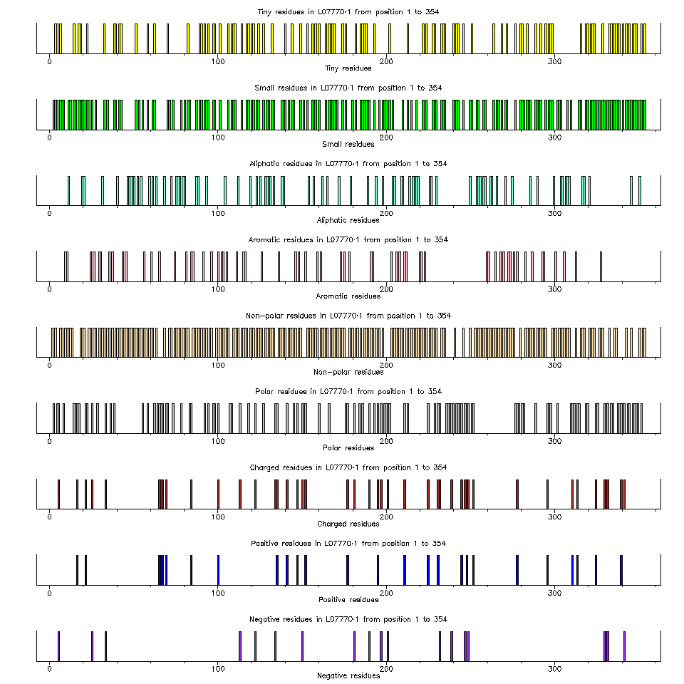
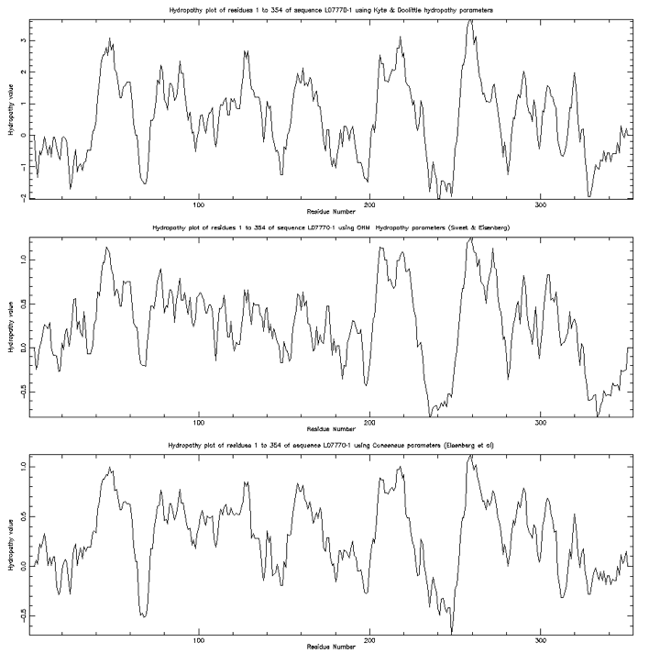

Predicting transmembrane regions
The results from the pepinfo hydropathy plot showed seven highly hydrophobic regions within xlrhodop.pep. Could these be transmembrane domains? We can use the EMBOSS program tmap to investigate this possibility:
Exercise: tmap
Program: tmap
Displays membrane spanning regions
Sequences file to be read in: xlrhodop.pep
Graph type [png]:
You will see a window that looks like this:
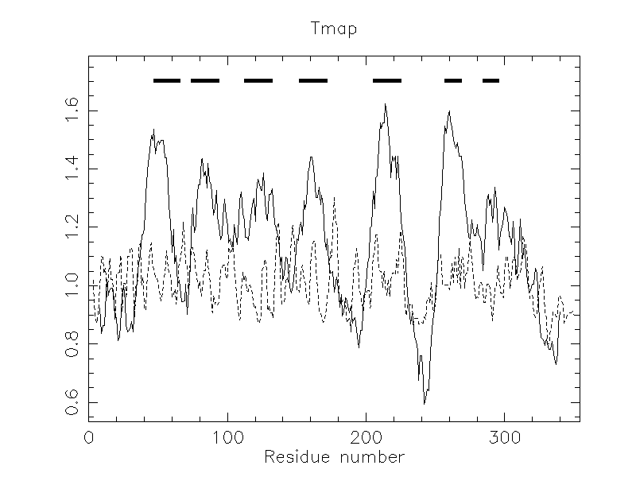
The bars across the top represent areas where transmembrane segments are predicted. Taken in combination with the results from pepinfo, we can see that there may be seven transmembrane helices in this protein.
There are various other programs you can use to analyze your peptide sequence - to find out what is available, try rerunning wossname as we did in the first chapter.

Pattern matching
In a number of cases, the active site of a protein can be recognized by a specific ``fingerprint'' or ``template'', a fairly small set of residues that are unique to a family of proteins. An example is the sequence GXGXXG (where G=glycine and X=any amino acid) which defines a GTP binding site. Searching for a (rather loose) predefined string of characters in a sequence is called Pattern Matching.
The EMBOSS program patmatmotifs looks for sequence motifs by searching with a pattern search algorithm through the given protein sequence for the patterns defined in the PROSITE database, compiled by Dr. Amos Bairoch at the University of Geneva. PROSITE is a database of protein families and domains, based on the observation that, while there are a huge number of different proteins, most of them can be grouped, on the basis of similarities in their sequences, into a limited number of families. Proteins or protein domains belonging to a particular family generally share functional attributes and are derived from a common ancestor.
Exercise: patmatmotifs
Program: patmatmotifs
Search a motif database with a protein sequence
Input sequence: xlrhodop.pep
Result:
########################################
# Program: patmatmotifs
# Rundate: Mon 21 Apr 2008 15:48:30
# Commandline: patmatmotifs
# -sequence xirhodop.pep
# -sbegin1 1
# -send1 354
# -nofull
# -prune
# -rformat dbmotif
# -auto
# Report_format: dbmotif
# Report_file: .patmatmotifs.08.04.21:15.48.29/l07770_1.patmatmotifs
########################################
#=======================================
#
# Sequence: L07770_1 from: 1 to: 354
# HitCount: 2
#
# Full: No
# Prune: Yes
# Data_file: /usr/ebiotools/share/EMBOSS/data/PROSITE/prosite.lines
#
#=======================================
Length = 17
Start = position 123 of sequence
End = position 139 of sequence
Motif = G_PROTEIN_RECEP_F1_1
TLGGEVALWSLVVLAVERYMVVCKPMA
| |
123 139
Length = 17
Start = position 290 of sequence
End = position 306 of sequence
Motif = OPSIN
PVFMTVPAFFAKSSAIYNPVIYIVLNK
| |
290 306
#---------------------------------------
#---------------------------------------
In our case we already know that our sequence is a rhodopsin. However, if you had an unknown sequence, we hope you can see that identifying motifs might provide you with information to help you plan further experiments.

Protein fingerprints
PRINTS is a database that defines functional protein families, identifying each domain by a number of short, particularly well conserved sequences. A full match to one of these "fingerprints" will match all the relevant short sequences in the correct order. A partial match is recorded if some are missing or if they occur in an incorrect order. The PRINTS database can be searched using the pscan program which is available within EMBOSS.
Exercise: pscan
Program: pscan
Scans proteins using PRINTS
Input sequence: xlrhodop.pep
Minimum number of elements per fingerprint [2]:
Maximum number of elements per fingerprint [20]:
Result:
CLASS 1
Fingerprints with all elements in order
Fingerprint GPCRRHODOPSN Elements 7
Accession number PR00237
Rhodopsin-like GPCR superfamily signature
Element 1 Threshold 54% Score 61%
Start position 39 Length 25
Element 2 Threshold 49% Score 49%
Start position 72 Length 22
Element 3 Threshold 48% Score 55%
Start position 117 Length 23
Element 4 Threshold 50% Score 69%
Start position 152 Length 22
Element 5 Threshold 51% Score 82%
Start position 204 Length 24
Element 6 Threshold 42% Score 72%
Start position 250 Length 25
Element 7 Threshold 46% Score 68%
Start position 288 Length 27
CLASS 2
All elements match but not all in the correct order
Fingerprint RHODOPSIN Elements 6
Accession number PR00579
Rhodopsin signature
Element 1 Threshold 80% Score 100%
Start position 3 Length 19
Element 2 Threshold 76% Score 94%
Start position 22 Length 17
Element 3 Threshold 53% Score 90%
Start position 85 Length 17
Element 4 Threshold 71% Score 100%
Start position 191 Length 17
Element 5 Threshold 56% Score 97%
Start position 271 Length 19
Element 6 Threshold 81% Score 95%
Start position 319 Length 14
CLASS 3 Not all elements match but those that do are in order
CLASS 4 Remaining partial matches

Multiple Sequence Analysis
The simultaneous alignment of many nucleotide or amino acid sequences is now an essential tool in molecular biology. Multiple alignments are used to find diagnostic patterns to characterize protein families; to detect or demonstrate homology between new sequences and existing families of sequences; to help predict the secondary and tertiary structures of the new sequences; to suggest oligonucleotide primers for PCR; and as an essential prelude to molecular evolutionary analysis.
One of the most popular programs for performing multiple sequence alignments is clustalw ( [1]). EMBOSS has an interface to clustal called emma clustal (and thus emma) creates a multiple sequence alignment from a group of related sequences using progressive pairwise alignments. It can also produce a dendogram showing the clustering relationships used to create the alignment.
The dendogram shows the order of the pairwise alignments of sequences and clusters of sequences that together generate the final alignment, but it is not an evolutionary tree, although the length of the branches is related to the relative distance of the sequences. clustal finds global optimal alignments. The alignment procedure begins with the pairwise alignment of the two most similar sequences, producing a cluster of two aligned sequences. This cluster can then be aligned to the next most related sequence or cluster of aligned sequences.Two clusters of sequences can be aligned by a simple extension of the pairwise alignment of two individual sequences. The final alignment is achieved by a series of progressive, pairwise alignments that include increasingly dissimilar sequences and clusters, until all sequences have been included in the final pairwise alignment. When gaps are inserted into a sequence to produce an alignment, they are inserted at the same position in all the sequences of the cluster. Each pairwise alignment uses the method of Needleman and Wunsch extended for use with clusters of aligned sequences.
pscan has told us that our sequence belongs to the rhodopsin family. This is a very large family of sequences - for example, you can see the Pfam entry for rhodopsin by doing a keyword search at http://www.sanger.ac.uk/Software/Pfam
We will now use some further members of the family from SwissProt and produce a multiple alignment; we'll then use this multiple alignment to produce a profile of this group of sequences and use that to align them all to our original sequence.
•Exercise: emma
•Exercise: prettyplot

Exercise: emma
Exercise: emma
Program: emma
Multiple alignment program - interface to ClustalW program
Input sequence: OPS2.fasta
Parameters:
type=protein
output=fasta
matrix=blosum
gapopen=10.000
gapext=5.000
gapdist=8
hgapresidues=GPSNDQEKR
maxdiv=30..
We have aligned OPS2_* sequences from two fruit fly species; two crab species, locust and scallop. Let's see what emma made of them. Open file output with a text editor.
Result:
>OPS2_DROME
MERSHLPETPFDLAHSGPRFQAQSSGNGSVLDNVLPDMAHLVNPYWSRFAPMDPMMSKIL
GLFTLAIMIISCCGNGVVVYIFGGTKSLRTPANLLVLNLAFSDFCMMASQSPVMIINFYY
-ETWVLGPLWCDIYAGCGSLFGCVSIWSMCMIAFDRYNVIVKGINGTPMTIKTSIMKILF
IWMMAVFWTVMPLIG-WSAYVPEGNLTACSIDYMTRMWNPRSYLITYSLFVYYTPLFLIC
YSYWFIIAAVAAHEKAMREQAKKMNVKSLRSSED-CDKSAEGKLAKVALTTISLWFMAWT
PYLVICYFGLFKIDG-LTPLTTIWGATFAKTSAVYNPIVYGISHPKYRIVLKEKCPMCVF
GNTDEPKPDAPASDTETTSEADSKA-----------------------------------
---------------------------
>OPS2_DROPS
MERSLLPEPPLAMALLGPRFEAQTGGNRSVLDNVLPDMAPLVNPHWSRFAPMDPTMSKIL
GLFTLVILIISCCGNGVVVYIFGGTKSLRTPANLLVLNLAFSDFCMMASQSPVMIINFYY
-ETWVLGPLWCDIYAACGSLFGCVSIWSMCMIAFDRYNVIVKGINGTPMTIKTSIMKIAF
IWMMAVFWTIMPLIG-WSSYVPEGNLTACSIDYMTRQWNPRSYLITYSLFVYYTPLFMIC
YSYWFIIATVAAHEKAMRDQAKKMNVKSLRSSED-CDKSAENKLAKVALTTISLWFMAWT
PYLIICYFGLFKIDG-LTPLTTIWGATFAKTSAVYNPIVYGISHPNDRLVLKEKCPMCVC
GTTDEPKPDAPPSDTETTSEAESKD-----------------------------------
---------------------------
>OPS2_LIMPO
----------MANQLSYSSLGWPYQPNASVVDTMPKEMLYMIHEHWYAFPPMNPLWYSIL
GVAMIILGIICVLGNGMVIYLMMTTKSLRTPTNLLVVNLAFSDFCMMAFMMPTMASNCFA
-ETWILGPFMCEVYGMAGSLFGCASIWSMVMITLDRYNVIVRGMAAAPLTHKKATLLLLF
VWIWSGGWTILPFFG-WSRYVPEGNLTSCTVDYLTKDWSSASYVIIYGLAVYFLPLITMI
YCYFFIVHAVAEHEKQLREQAKKMNVASLRANADQQKQSAECRLAKVAMMTVGLWFMAWT
PYLIIAWAGVFSSGTRLTPLATIWGSVFAKANSCYNPIVYGISHPRYKAALYQRFPSLAC
GSGESGSDVKSEASATMTMEEKPKSPEA--------------------------------
---------------------------
>OPS2_HEMSA
---MTNATGPQMAYYGAASMDFGYPEGVSIVDFVRPEIKPYVHQHWYNYPPVNPMWHYLL
GVIYLFLGTVSIFGNGLVIYLFNKSAALRTPANILVVNLALSDLIMLTTNVPFFTYNCFS
GGVWMFSPQYCEIYACLGAITGVCSIWLLCMISFDRYNIICNGFNGPKLTTGKAVVFALI
SWVIAIGCALPPFFG-WGNYILEGILDSCSYDYLTQDFNTFSYNIFIFVFDYFLPAAIIV
FSYVFIVKAIFAHEAAMRAQAKKMNVSTLRSNEA-DAQRAEIRIAKTALVNVSLWFICWT
PYALISLKGVMGDTSGITPLVSTLPALLAKSCSCYNPFVYAISHPKYRLAITQHLPWFCV
HETETKSNDDSQSNSTVAQDKA--------------------------------------
---------------------------
>OPS2_SCHGR
-----MVNTTDFYPVPAAMAYESSVGLPLLGWNVPTEHLDLVHPHWRSFQVPNKYWHFGL
AFVYFMLMCMSSLGNGIVLWIYATTKSIRTPSNMFIVNLALFDVLMLLEMPMLVVSSLFY
-QRPVGWELGCDIYAALGSVAGIGSAINNAAIAFDRYRTISCPIDG-RLTQGQVLALIAG
TWVWTLPFTLMPLLRIWSRFTAEGFLTTCSFDYLTDDEDTKVFVGCIFAWSYAFPLCLIC
CFYYRLIGAVREHEKMLRDQAKKMNVKSLQSNADTEAQSAEIRIAKVALTIFFLFLCSWT
PYAVVAMIGAFGNRAALTPLSTMIPAVTAKIVSCIDPWVYAINHPRFRAEVQKRMKWLHL
GEDARSSKSDTSSTATDRTVGNVSASA---------------------------------
---------------------------
>OPS2_PATYE
--------------------------------------MPFPLNRTDTALVISPSEFRII
GIFISICCIIGVLGNLLIIIVFAKRRSVRRPINFFVLNLAVSDLIVALLGYPMTAASAFS
-NRWIFDNIGCKIYAFLCFNSGVISIMTHAALSFCRYIIICQYGYRKKITQTTVLRTLFS
IWSFAMFWTLSPLFG-WSSYVIEVVPVSCSVNWYGHGLGDVSYTISVIVAVYVFPLSIIV
FSYGMILQEKVCKD------SRKNGIRAQQRYTPRFIQDIEQRVTFISFLMMAAFMVAWT
PYAIMSALAIGSFNV--ENSFAALPTLFAKASCAYNPFIYAFTNANFRDTVVEIMAPWTT
RRVGVSTLPWPQVTYYPRRRTSAVNTTDIEFPDDNIFIVNSSVNGPTVKREKIVQRNPIN
VRLGIKIEPRDSRAATENTFTADFSVI
The sequences are very similar, but there are some differences - note the gaps that have been inserted. Also note that since this is a global alignment algorithm, gaps have been inserted to make all the sequences the same length.
Differences in alignment can be very difficult to see in this format. The program Prettyplot can enhance visualisation of your results, by aligning the sequences on top of one another. Save the results as OSP2.aln.

Exercise: prettyplot
Open OPS2.aln in prettyplot!
Exercise: prettyplot
Program: prettyplot
Displays aligned sequences, with coloring and boxing
Input sequence set: OPS2.aln
Graph type [png]:
You will obtain two png images. Identical residues are shown in red, and similar residues in green. This type of display can give you a first impression of regions of conservation.
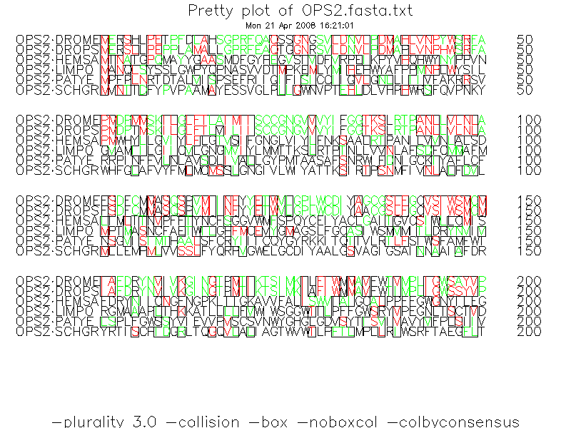
Alternatively the output from multiple alignment can be opened in Jalview.

Bibliography
1
D.G. Higgins J.D. Thompson and T.J. Gibson.
CLUSTAL W: improving the sensitivity of progressive multiple sequence alignment through sequence weighting, position specific gap penalties and weight matrix choice. Nucleic Acids Research., 22:4673-4680, 1994.
2
A.D. McClachlan M. Gribskov and D. Eisenberg.
Profile analysis - detection of distantly related proteins. .
Proc. Natl. Acad. Sci. USA, 84:4355-4358, 1987.
3
S.B. Needlman and C.D. Wunsch.
A general method applicable to the search for similarities in the amino acid sequence of two proteins. .
J. Mol. Biol., 48:443-453, 1970.
4
T.F. Smith and M.S. Waterman.
Identification of common molecular subsequences.
J. Mol. Biol., 147:195-197, 1981.
About this tutorial ...
Introduction to Sequence Analysis using wEMBOSS
This documents were originally prepared for the command line EMBOSS.
The first version of this document was generated using the LaTeX2HTML translator Version 98.1p1 release (March 2nd, 1998)
Copyright © 1993, 1994, 1995, 1996, 1997, Nikos Drakos, Computer Based Learning Unit, University of Leeds.
The command line arguments were: latex2html emboss_tutorial.tex.
The translation was initiated by EMBnet on 2003-09-10
Changed for wEMBOSS September 2007 by Erik Bongcam-Rudloff using iWeb on MacOSX.
Latest version 19 September 2007.

